**CEDAR COUNTY**

**HISTORICAL**

**MUSEUM**

*Established 1964*

**Membership Dues**

Annual dues of $10 per person are collected every January from our supporting members.

**Financial Resources**

* Annual Membership Dues
* Individual and Family donations.
* Memorials (see website for details).
* Cedar County Tourism Grants.
* Hartington Community Foundation Grants.
* County support for residence, utilities and upkeep.

**Museum Available For:**

Single, Family, Group and School Tours. Educational, Private and

Media Events. Family and Genealogy Research and Local History.

Congue nihil imperdiet doming id quod mazim placera

t facer minim veni am ut wisi enim ad minimeniam, quis erat nostr uexe

rci tation ullamcorper nostru exerci tation ullam corper et iusto odio dig nissim qui blandit praesent lupta. Tummer delenit

augue duis dolore te feugait nulla facilisi. Con erattis sectetuer adip iscing elit, sed erat diam nonummy nibh magna erat.

***Our Mission***

***"Dedicated to preserving the history of Cedar County, Nebraska through the preservation of its historical past "***

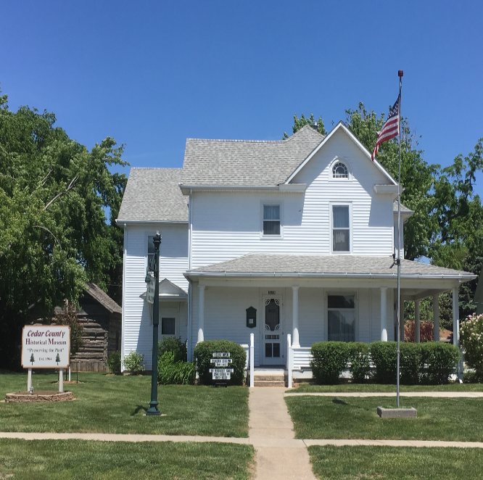

The main museum pictured on the front is the original Victorian Style home built in 1900 by Henry Stuckenhoff. This was the home of Anton Kaspar “AK”Lammers and wife Clara (Walz) Lammers, along with their 4 daughters: Aurelia, Gertrude, Dolores and Kathryne. The daughters donated the land, home and the carriage barn in memory of their parents in 1964 giving a home to

the many historical treasures

from Cedar County families.

**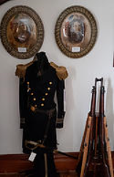

**304 West Franklin**

**PO Box 181**

**Hartington, NE 68739**

**Hours Open**

Sundays 2-4 pm (May-August) &

Tours by Request (Year Round)

or for Information Call and Leave a Message for Laurie:

(402) 254-6597 or (402) 841-6301

**www.cedarcountynehistoricalmuseum.com**

*www.*cedarcountynehistoricalmuseum

**www. cedarcountynehistoricalmuseum.com**

All Donations are

Greatly Appreciated!

Victorian Home

The heart of the home is vibrant with living areas still set from the 1900’s. Featuring the living, kitchen, bathroom, and bedroom areas. Marvel in the music, sewing and fashion rooms. The doctor’s office and military rooms are a definite must see! Capture some history from the town room, office and school rooms. See the notorious dining room where Clara Lammers sat 24 people for elegant dining and check out our rental options for your next small gathering.

**Log Cabin**

**Carriage barn**

:

**Over**

Exhibit Building

A large Exhibit Building was built in 1999 to display more items, especially the larger exhibits. Originally, the building was not insulated, causing wide variance in temperatures through the year. In 2018, grant money and museum savings allowed the opportunity to install a new ceiling with insulation, new lighting, insulated paneled and painted walls, improved shelving and display cases. The building is now one of our most enjoyed attractions, with its many unique items including a two headed pig and an eight legged lamb.

Don’t miss the two headed pig or the eight legged lamb!

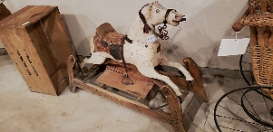

**Donating Items to the Museum:**

Items of historical quality are welcome for display and ultimate review by the committee for addition to the museum. Please contact Laurie at 402-254-6597 or

402-841-6301

Carriage Barn

Built in 1900, the barn originally contained stalls and housed horses and the horse carriage until the

advent of the automobile. The barn has been used as a haven for storage of historical items that

 were too large be on display.In 2019, the barn was restored to again display items on the first

floor and be open for tours.

**Board**

Chairman-Julie Meirose

Dan Kathol

Darrell Kathol

In 1982, Marvin Sudbeck and his wife Rita donated and moved the cabin to the Cedar County Historical Society. Future plans are to restore the cabin as money becomes available and furnish it so that it too can be open for tours.

**Over 5,000 Items**

**on Display !**

Log Cabin

The Log Cabin was built by Herman Sudbeck in 1869 and was originally located one mile west of Bow Valley.  Herman and his wife Maria and their five children lived in the cabin. Herman lived in the cabin until his death in 1901 and son Bernard continued to live in the cabin till the early 1920’s. In 1925, John and Wilhemina Feilmeier rented the cabin for a year before moving and the cabin sat vacant as it is today.

**Officers**

President-Laurie Kathol

V.P.- Alice Pommer

Secretary-Elaine Arens

Treasurer-Dan Kathol